Biology 3B: Energy Flow in Ecosystems

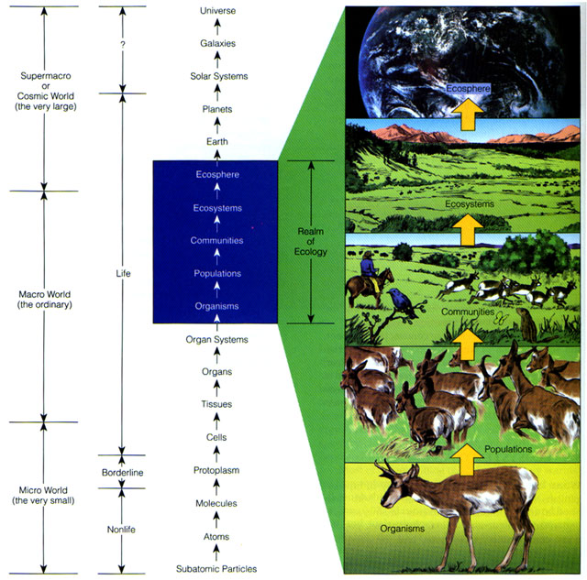
Introduction
All plants and animals need energy for growth, metabolic processes (like staying warm), and reproduction. Plants and animals also get their energy by converting potential energy stored in chemical bonds. For plants, energy is provided by the sun and triggers photosynthetic reactions that allow plants to form simple carbohydrates (like glucose) from CO₂ and water. These carbohydrates store energy for future use. Animals that eat plants (herbivores) assimilate the carbohydrates found in the plants and use those for energy. And carnivores eat other animals and assimilate the energy that was stored in those critters. This supplemental reading addresses energy in ecosystems, how that energy is stored, and how it is passed along from plants to animals—and ultimately to us!

Energy in Ecosystems
Before we delve too deeply into energy flow in ecosystems, we should understand what ecosystems are. Ecosystems are defined as a community of different species interacting with one another and with their nonliving environment of matter and energy. Ecology is the study of the relationships between organisms and their environment. (Etymological note: the word ecology comes from the Greek oikos meaning “house” + logos meaning “study of”). There is no correct size of an ecosystem—its size is somewhat arbitrary. Ecosystems are often defined by the area we wish to study.

Produce-Consumer Chains
Since ecosystems are defined by the interaction of species among each other, another important component of ecosystems are species relationships. One of the most critical relationships is that of producer and consumer.

Producers (also called autrotrophs = "self–feeders") make their own food from compounds obtained in the environment. Plants are producers. They capture sunlight to make sugars and other organic compounds in the photosynthetic process. Chemosynthetic bacteria are also producers, as they can convert simple compounds into complex nutrient compounds to feed themselves without sunlight.

Consumers (also called heterotrophs = "other–feeders") get their energy and nutrients by feeding on other organisms. Consumers include herbivores (who eat producers), carnivores (who eat other consumers), omnivores (who eat both producers and consumers), and detritivores (or decomposers, who eat dead matter). For most consumers, complex carbohydrates are converted into energy via aerobic respiration that occurs in the cells of these organisms. In respiration, organic molecules (e.g., glucose) are combined with oxygen to produce carbon dioxide, water, and energy in a process that is almost the reverse of photosynthesis.

Glucose + oxygen carbon dioxide + water + energy
C₆H₁₂O₆ + O₂ 6 CO₂ + 6 H₂O + energy

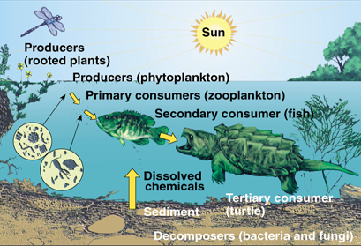
These producers, consumers, and decomposers are continuously cycling matter and energy through their ecosystem. Figures 2 and 3 depict these producer-consumer relationships for an aquatic and terrestrial ecosystem, respectively.

As shown in Figures 2 and 3, we can also categorize consumers based on the plants or animals they eat. Primary consumers are herbivores those that feed directly on producers. Secondary consumers are carnivores that feed on primary consumers. Tertiary consumers feed only on carnivores.
Figure 2. Producer-consumer relationships for an aquatic ecosystem
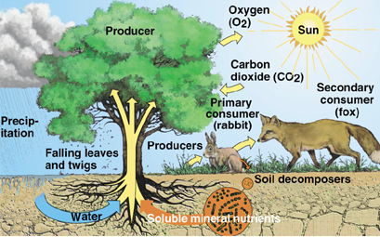
Note that some animals (like humans) can be primary (think salad), secondary (think rabbit stew), or tertiary consumers (think gator bites)! We can also divide the decomposers into two groups: decomposers that consume remains and wastes of other organisms and complete the breakdown and recycling of organic materials; and detritivores which feed on detritus (partially decomposed organic matter, such as leaf litter and animal dung). Figure 4 identifies examples of decomposers and detritivores. For this reading we will refer to these groups as one.
Figure 3. Producer-consumer relationships for a terrestrial ecosystem.

Food chains and energy flow
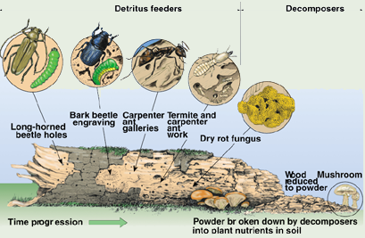
As we have seen, energy is stored by producers and passed through to consumers by means of a food chain. That is, solar energy is captured by plants, which assimilate that energy and store it as plant tissue. This plant tissue is eaten by herbivores, which assimilate the energy into their own animal tissue. That herbivore’s tissue is then eaten by a carnivore who assimilates that energy and stores it as carnivore animal tissue. Ultimately, the energy stored in the carnivore is returned to the ecosystem when that animal dies and decomposes.

Each level in a food chain is called a trophic level. All organisms that obtain their energy in the same number of steps from the sun are in the same tropic level. The first trophic level represents the primary producers. The second trophic level represents the herbivores (or primary consumers). The third trophic level represents the carnivores (secondary consumers). A fourth trophic level would be a group of organisms that feed off of the third trophic level—these organisms would be considered tertiary consumers. These relationships are depicted in Figure 5.
Figure 4. Distinction between decomposers and detritivores.

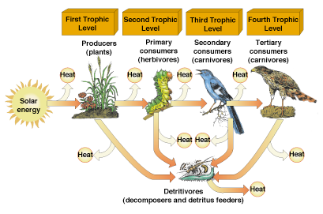
We have already seen that not all the energy available at one level (e.g., the producer level) is available to higher levels (the consumer level). The second law of thermodynamics, which states that we cannot transfer energy from one form to another without loss, is a formal way of saying that some of the energy is released along the chain due to waste and respiration. Just as in a steam plant, as energy goes from one stage (or organism) the next (another organism) in the form of food, a large part is degraded as heat through metabolic activity. As another example of this energy degradation Figure 6 shows the energy flow in a grassland ecosystem.
Figure 5. Trophic levels for a simple food chain.

The energy pyramid
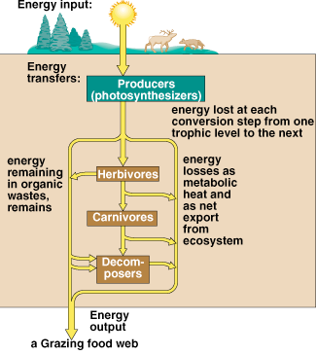
If you study Figures 7 and 8, you will notice that one implication is that higher trophic levels have less energy available to them than lower trophic levels. Because energy is degraded as it moves from one trophic level to the next, the amount that is stored in animal tissue at high trophic levels is much less than that received by producers. This concept is reflected in the energy pyramid. An energy pyramid is shown in Figure 7, where there is a 90% loss in energy as it flows from one trophic level to another. Notice that the producers start with 10,000 units of available energy, but due to energy loss only 10 units get to the tertiary consumers. This is one reason why most ecosystems have lower populations of high-level consumers compared to low-level consumers.
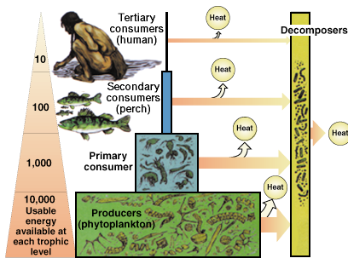
Figure 7. The Energy Pyramid

Figure 6. Energy flow for a grassland system.

In nature, the efficiency of energy flows from one trophic level to the next varies from 5% to 20% (that is, we expect a 95% to 80% loss of energy). Figure 8 depicts energy flows for another system where top carnivores receive only about 21 units of energy from a total input of 1,700,000!
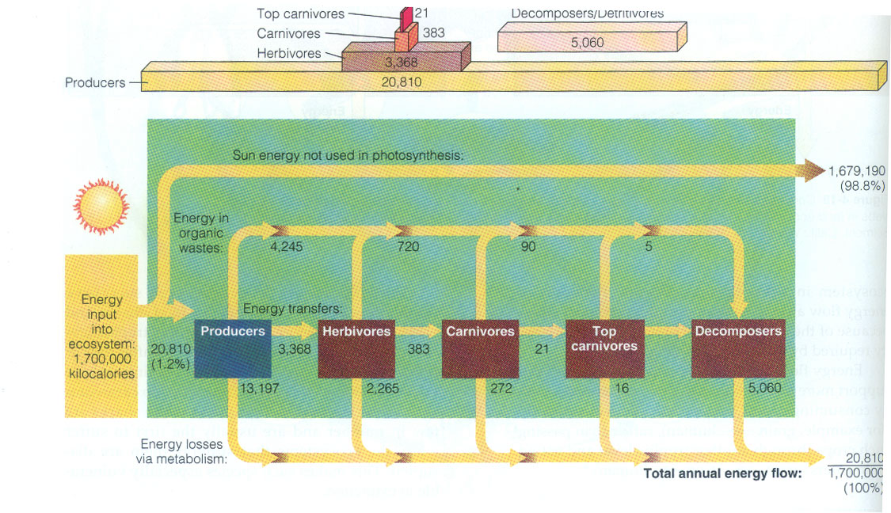

Figure 8. The Energy pyramid with numbers

